**Plan For A Website App**

* + - What is the purpose of the App?
    - What does it do?
    - What does it look like?
    - What is its navigation?
    - What it will need to be accessible by users?
    - What's the target audience?

Description

Purpose and What It Will Do

The purpose of the app would be to review games, share information on upcoming games and gaming news. The app will allow you to go the page of your chose within the app when you click on the link for that section of the app, the app will show images of the games you are reading about on the review or gaming news sections of the app as well as give you information on each section though the homepage.

Basic look

Homepage: The name of the app will be at the top of the app and will have the bar with the links to the other sections and the logo of the app underneath it. Under that there will be information on the 3 different sections.

Review Page: The top bar will be the same as the homepage but with a link to the homepage rather than a link to the review page. Then there will be the title of the section, title of the game along with a photo to show what the game is, then the review of the game will be underneath that (this will continue for each game).

Upcoming Games Page: The top bar will be the same as the homepage but with a link to the homepage rather than a link to the Upcoming page. Underneath that there will be the title for the section, then title of the list along with what month will be counted on the list. Then the list will consist of the title of the game along with its intended release data or just the month if the release data has not been fully confirmed.

News Page: The top bar will be the same as the homepage but with a link to the homepage rather than a link to the gaming news page. Underneath the bar will be the title of the section and then the news title after that. Then a photo relating to the gaming news also with a summary of what the news was about.

Navigation

The navigation will work though each page having a link the other sections of the app and having Homepage replace the link of the page the user is currently on.

Target Audience

The target audience for this app will be gamers and developers. It has when games are coming out and news about the gaming scene which will gain the interest of your average gamer as well as reviews on games which may interest developers who want to know how a game did.

**What I will uses**

HTML: HTML will be used to program the basic look of my website and what will ass be in it. This is because html is used to make the basic structure of a website.

CSS: CSS will be used to give the HTML website the look it will have. CSS is used to program in how a webpage will look such as colour, font, text size, etc.

**Wireframe for website pages**

Home Page

<https://wireframe.cc/4CIe4R>

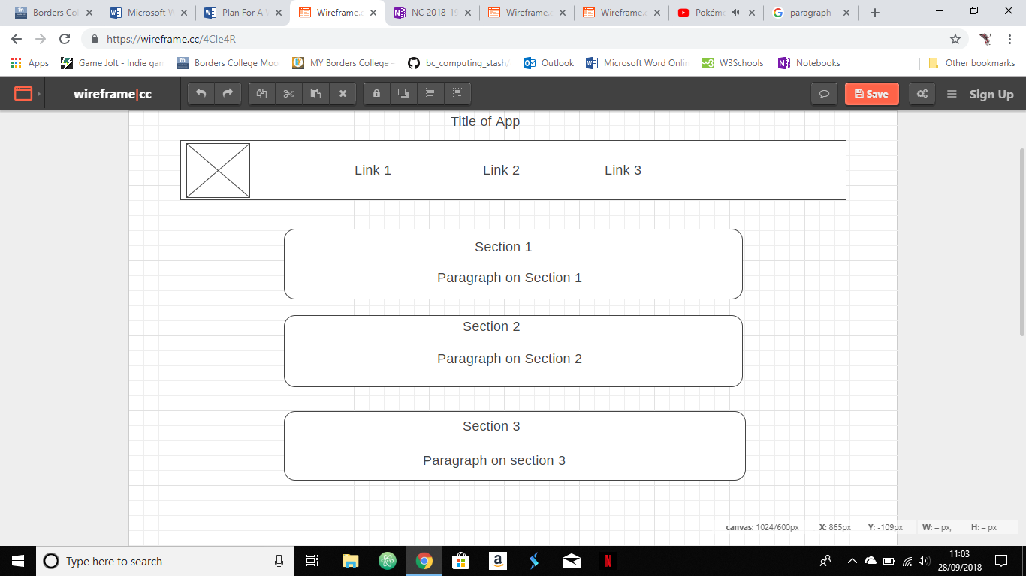

Review Page

<https://wireframe.cc/EGTCU4>

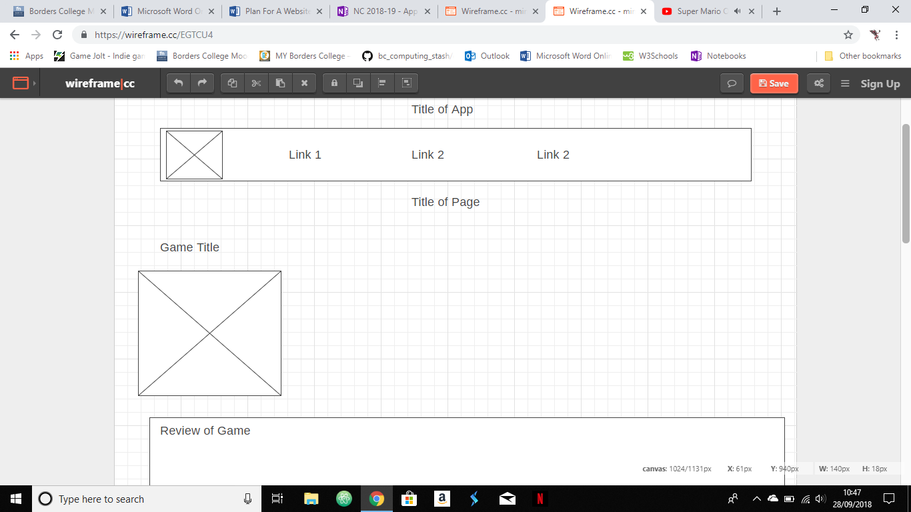

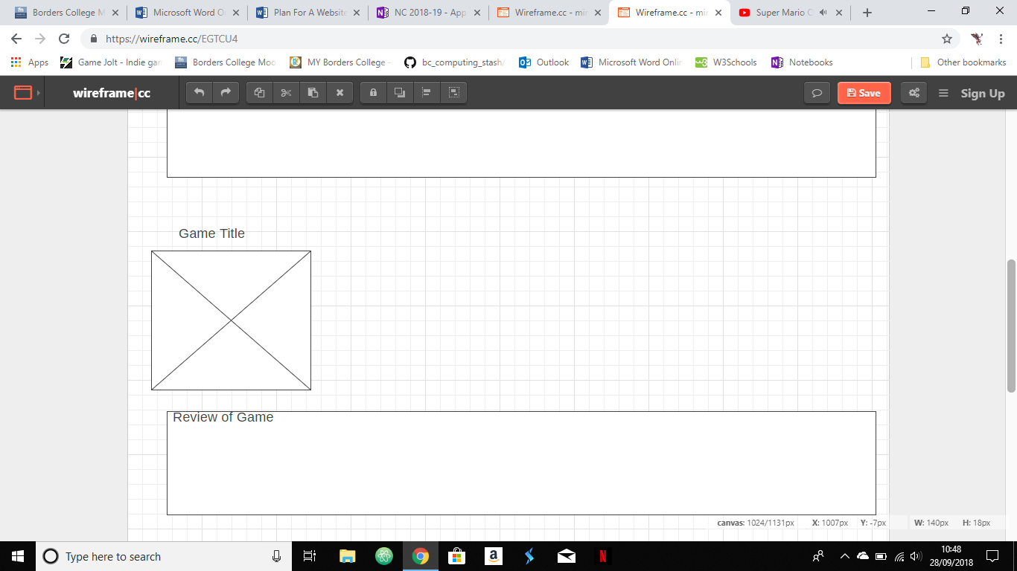

Upcoming Games Page

<https://wireframe.cc/IzKauF>

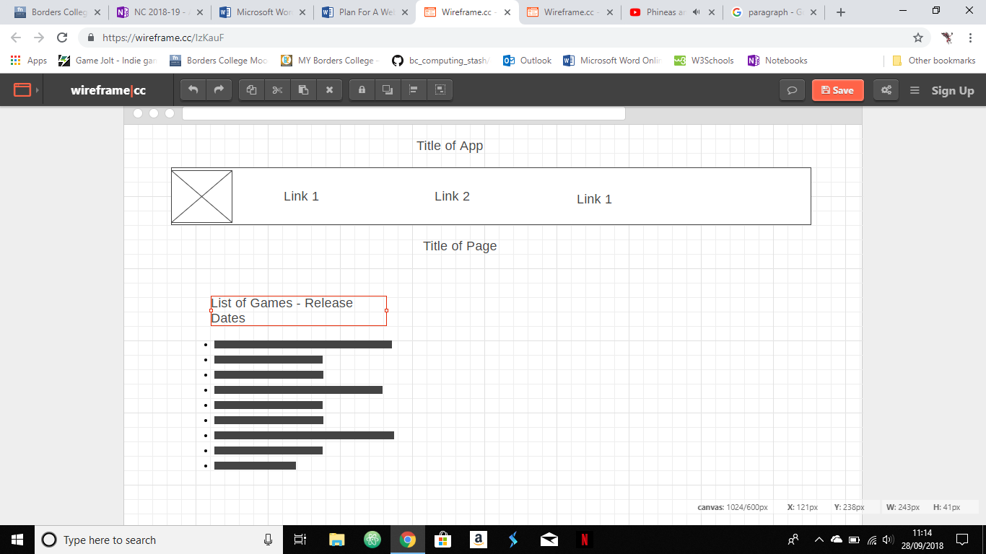

News Page

<https://wireframe.cc/hLP6Ut>

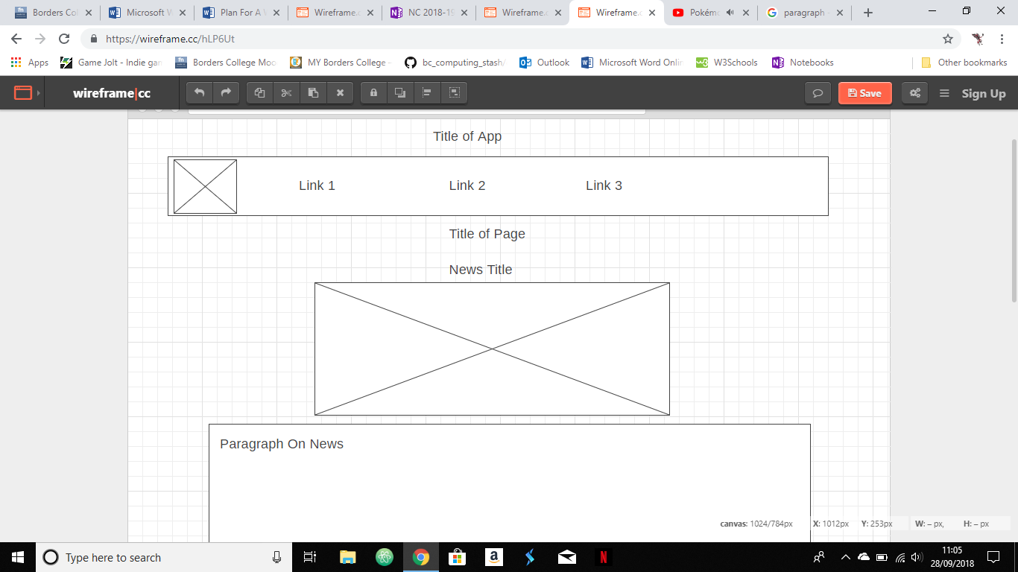

Navigation

